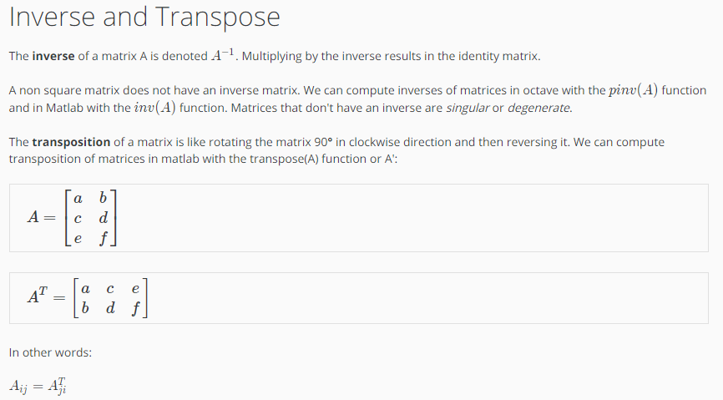
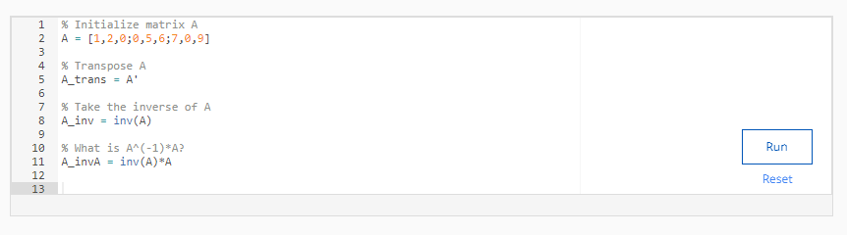

CODE:
% Initialize matrix A
A = [1,2,0;0,5,6;7,0,9]

% Transpose A
A_trans = A'

% Take the inverse of A
A_inv = inv(A)

% What is A^(-1)*A?
A_invA = inv(A)*A

OUTPUT:
